Butterflies Summer 1 Knowledge Overview

Phase 1 – Houses and Homes

**Learning opportunities**

During this half term we will be learning about our environment. We will be thinking about the planet we live on, the country, county, and city we live in. We will look at different types of houses and homes both within this country and other countries, how they are constructed and the materials that are used. We will investigate the use of maps and create some maps to help us find our way around our environment.

We will also think about the type of homes animals have. We will watch the growth of a caterpillar and its metamorphosis into a Butterfly. We will continue to care for our beanstalks and watch their growth.

We will also be learning about the number 5, counting to 5 and beyond and using our mathematical knowledge to problem solve.

Words of Wisdom:

|  |  |
| --- | --- |
| Earth |  |
| Map |  |
| City/Leicester |  |
| County/Leicestershire |  |
| Country/England |  |
| House/Home |  |
| Environment |  |
| Bungalow |  |
| Cottage |  |

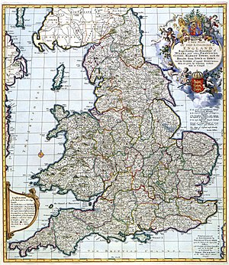

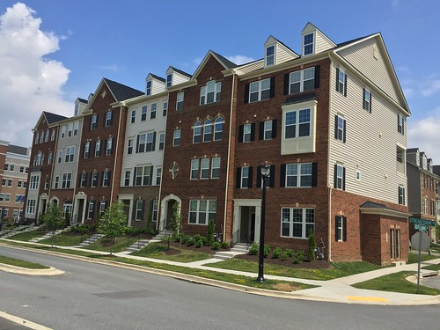

**We will be reading:**

* Me on a Map – Joan Sweeny
* Window – Jeannie Baker
* Hairy Mc Clary from Donaldson Dairy – Lynley Dodd
* Home – Patricia Hegarty
* The Very Hungry Caterpillar – Eric Carl
* The three little Pigs – (Traditional Tale)

**How can you support this topic at home?**

Talk to your child about where they live, what type of house do you live in, does it have stairs, how many bedrooms does it have, do you have a garden?

* Draw a simple map of your house, can your child follow the map to find some treasure.
* Talk to your child about their route to school, using some positional language such as - first we turn right out of the house, then we walk down, then we turn left.
* Share some of the books we will be reading with your child. (Your local library will have copies of them, or the stories are available on you tube)