Caterpillars– Spring 1 Knowledge Overview

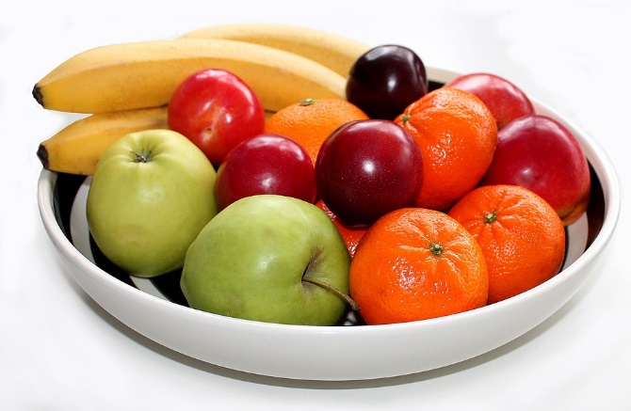Phase 1 - Foods

Words of Wisdom:

|  |  |
| --- | --- |
| Graceful Swans |  |
| Cocoon |  |
| Beanstalk |  |
| Mango |  |
| Cottage |  |
| Woods |  |

**Learning opportunities**

At the beginning of this term, the focus will be getting to know your children, their likes and dislikes, their favourite activities and helping them to getting to a new routine. While doing this the children will also be learning about different foods using different story books each week. This will build their love for reading as well learn new words they may have not come across before. The children will have opportunities to learn where food comes from, what is healthy for them and how to grow their own vegetables.

**How can you support this topic at home?**

* Bring photos from home of your child enjoying their favourite meal so we can talk about them in class.
* Explore new foods as a family and talk about different textures, if you like or dislike them.
* Involve your child with food shopping and preparing meals for the family.
* There is a link of more exciting activities <https://www.teachingexpertise.com/classroom-ideas/nutrition-activities-for-preschoolers/>

**We will be reading:**

* Listen to Winter – Morena Forza
* Hungry Caterpillar – Eric Carle
* Jasper’s Beanstalk – Nick Butterworth & Mick Inkpen
* Handa Surprise – Eileen Browne
* Golilocks and the three bears – Mike and Carl Gordon
* Teddy Bear picnic – Baxter Nicola